Quad Rotor
By Kevin Ross | BEng(Hons) | MIET | CLD
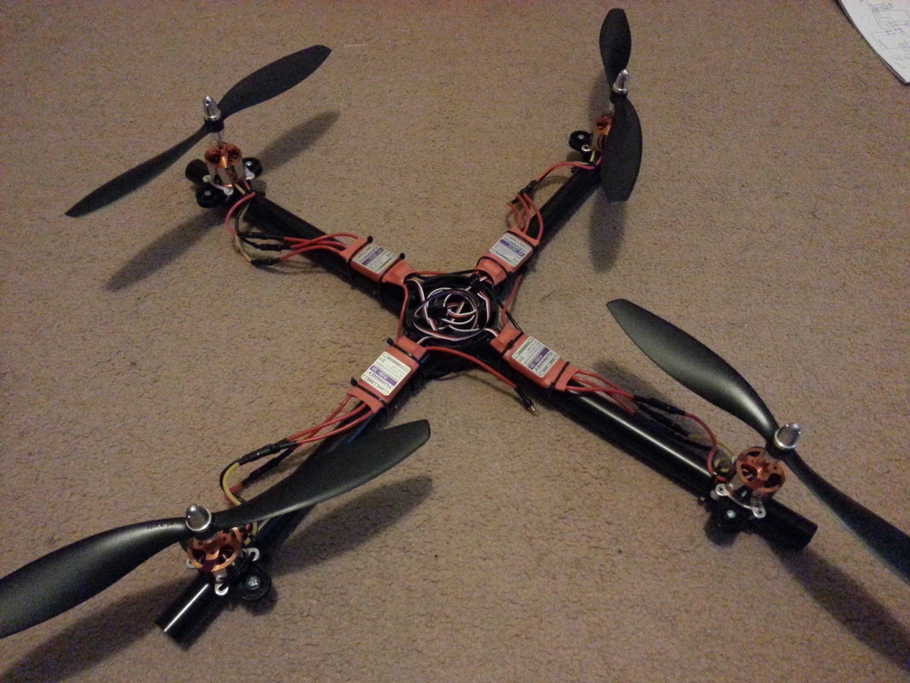

Contents
Summary 3
Introduction/Terms of reference/Scope 3
Procedure 4
Hardware 4
Software 5
System diagram 6
Stages of design 6
1. Research and POC 6
2. Build Frame 8
3. Turnigy Plush 8
4. LiPo Battery 8
5. Inertial Measurement Units (IMU) 9
MPU 6050 (GY-521) 9
GY-80 9
6. Bluetooth Module HC-06 10
7. PID 11
Findings 11
Conclusion 11
Problems 11
Recommendations 11
References/bibliography 12
L3G4200D 12
ADXL345 12
HMC5883L 12
BMP085 12
Appendices 12

Summary

Introduction/Terms of reference/Scope
Build a quad-rotor as cheaply as possible. Using materials that are easily available to hobbyist. Also to learn control theory, PID and implementing this is C code that will be run on an Arduino (Atmega 328) Uno or Nano.

Procedure

Hardware
Hardware | Description | Image
Arduino Uno | £20
4 ESC Turnigy Plush | $13.13 | 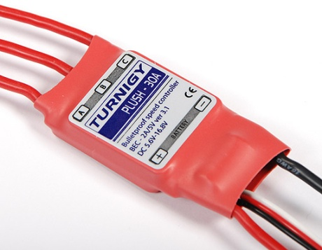
4 DC Brushless motors, D2830-11 1000kv | $9.93 | 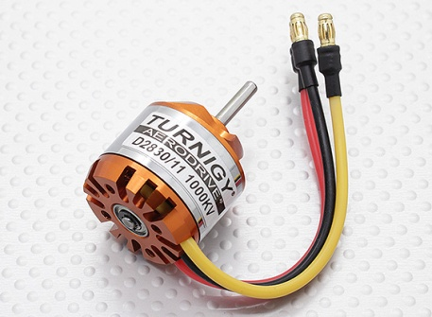
MPU 6050 (GY 521) | £5 | 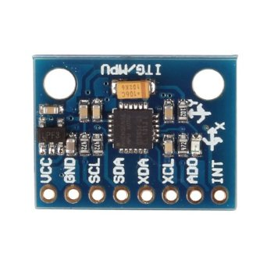
GY 80 | £25 | 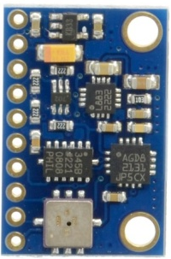
Bluetooth to serial HC-06 | £7 | 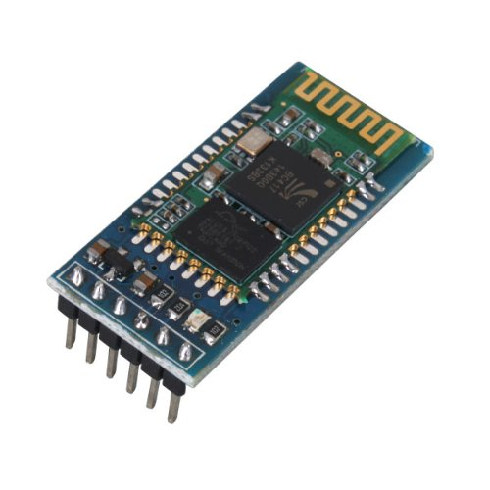
20mm Conduit Pipe 2m | £1.78
20mm 4 way conduit box | £1.92 TLC | 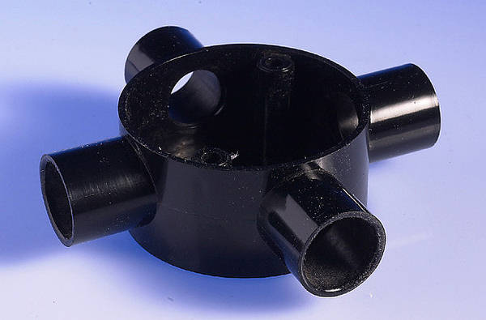
Propellers |  | 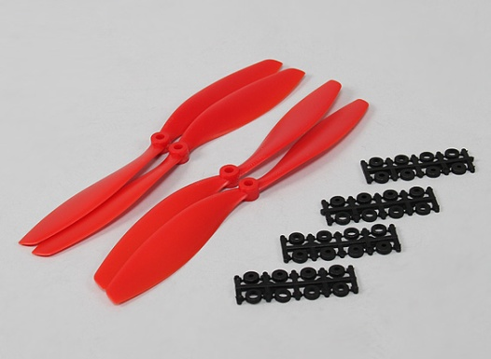
20mm conduit spacer bar saddle |  | 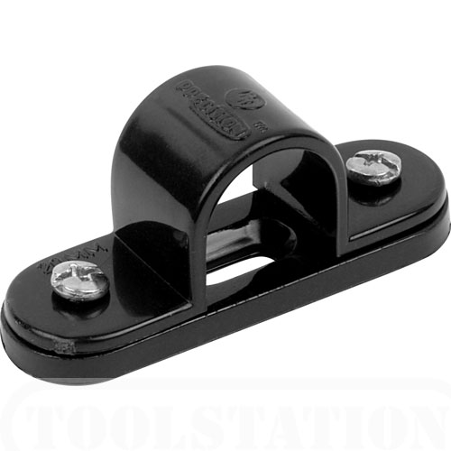
Orange T-Six |  | 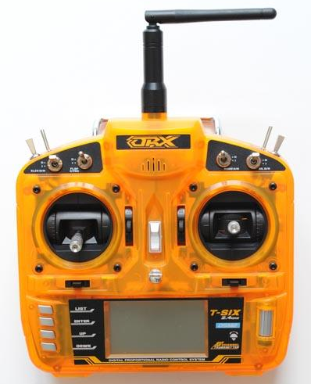
Orange R620 |  | 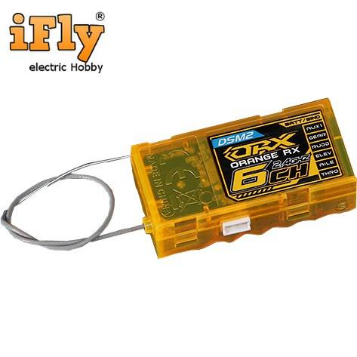

Software
Software | Description | Image
NI LabVIEW
Arduino IDE
PuTTY

System diagram
Software

Hardware

Stages of design

Research and POC
Purchased an Electronic Speed Controller (ESC) Turningy MultiStar 30A, Turnigy 1000kV brushless motor, LiPo 2.2A 20c-30c and MPU 6050.
For a brushless DC motor to operate it requires a Pulse Width Modulated (PWM) signal. Outputting a PWM signal from an Arduino is simple.
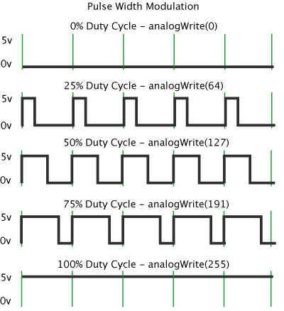
Figure 1: http://arduino.cc/en/Tutorial/PWM

int ledPin = 9; // LED connected to digital pin 9
int analogPin = 3; // potentiometer connected to analog pin 3
int val = 0; // variable to store the read value

void setup()
{
pinMode(ledPin, OUTPUT); // sets the pin as output
}

void loop()
{
val = analogRead(analogPin); // read the input pin
analogWrite(ledPin, val / 4); // analogRead values go from 0 to 1023, analogWrite values from 0 to 255

Once I was able to gain control of the motor, I could then consider the propellers.

Build Frame
The frame is built from 20mm PVC conduit, a 4 way junction box, and 4 20mm spacer saddles.
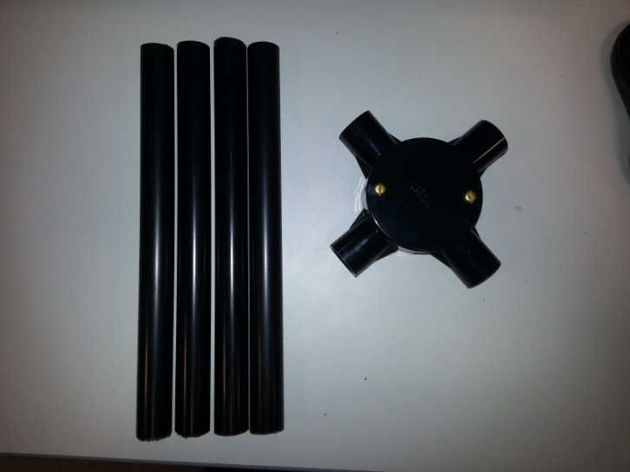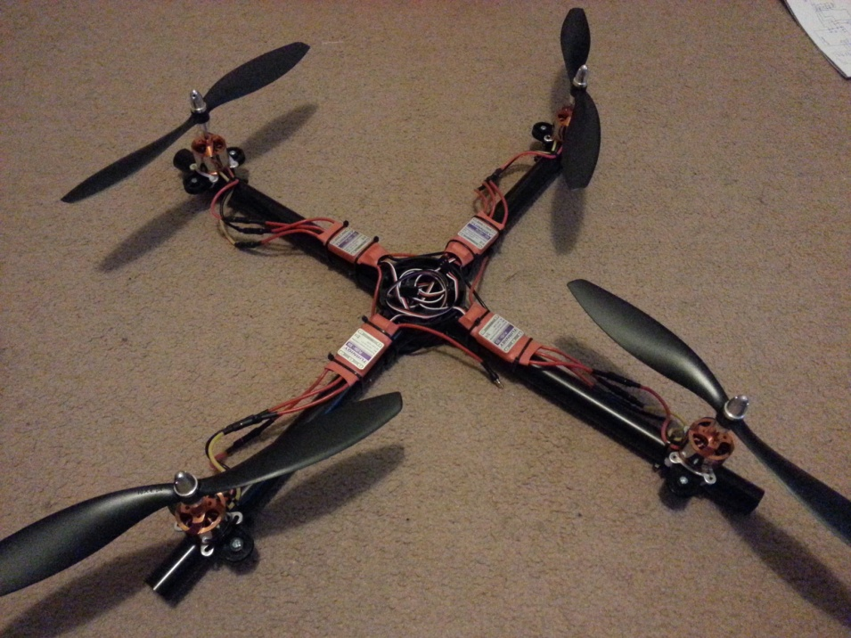

I started out with this basic frame design, to prove the concept that the basic materials will be suitable to make the X frame. I then evolved the quadcopter design, creating a 3D model in google Sketchup. This allowed me model the quadcopter and make changes to the design as I wanted.
Once I was happy with the design I was able to build the frame.

Turnigy Plush
Speed controllers require a start-up sequence to arm them.

LiPo Battery
Max Current = Discharge Rate X Capacity

Inertial Measurement Units (IMU)

Accelerometer
Accelerometers are able to measure orientation of the device with respect to the surface of the earth. However they tend to be very sensitive. As a result the vibration from the motor can give us offset with the orientation.
Gyroscope
Gyroscopes provide us with rotational movement. However gyroscopes are subject to drift, which will mean that the result may not return to 0 degrees.
Magnetometer
A Magnetometer measures the direction and the strength of the earth’s magnetic field. From the sensor magnetic north and South Pole can be determined.

These sensors alone are not enough to give stable pitch, roll and yaw value. However combining the results from the sensors can. For pitch and roll combining the accelerometer and gyro scope can give stable value. For yaw combining the magnetometer with the gyroscope will again give a stable value.

MPU 6050 (GY-521)
MPU 6050 is a module that has 6 DOF (Degrees of freedom) it has a 3 axis accelerometer and a 3 axis Gyroscope.
Limitation is that yaw cannot be accurately calculated with just an accelerometer and gyro. In order to accurately calculate yaw, a magnetometer is required.
Great as was cheap and allowed for initial PID testing for Pitch and roll

GY-80
10 DOF

Triple Axis Magnetometer HMC5883L
Get Raw Data
will read the raw data from the registers. As the register are 8bit registers data is acquired in two halves to make a 16bit word.
Get Scaled Compass Value
Scales the raw value read from the digital compass. The scale value is set depending on the gain value that has been set.
Calculate heading
$atan2\left(y,x\right)=2acrtan\frac{\sqrt{x^{2}+y^{2}−x}}{y}$
$heading=atan2\left(scaledMagY,scaledMagX\right)$
Angle Declination
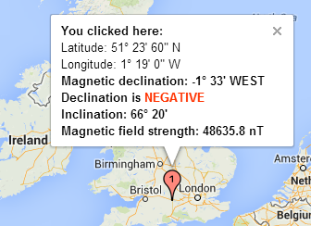
Magnetic Declination -1° 33’
Needs to be converted to radians in order to be factored in for the equation.
1 degree = 0.01745328 radians
-1 degree = -0.01745328 radians

33’ = 33 arc minutes
1 arc minute = 0.000290888209 radians
33 arc minutes = 0.00959931 radians

-1° 33’ = -0.01745328 + 0.00959931 radians
= -0.00785397 radians

Correct for when signs are reversed
if the sign is negative find the positive value.
Check for wrap due to addition of declination
If the heading value is greater than 2PI find the corresponding value in the range.
Convert radians to degrees
1 radian = 57.29577795

Triple Accelerometer ADXL345
Get accelerometer values
Scale value
2g range scale 256 1/256 = scale multiplier see data sheet
Get angles from accelerometer (Radians)
${AngleX}_{Accel}=atan\left(\frac{−1∗{Accel}_{Y}}{\sqrt{{Accel}_{X}+{Accel}_{Y}}}\right)$
${AngleY}_{Accel}=atan\left(\frac{{Accel}_{X}}{\sqrt{{Accel}_{Y}+{Accel}_{Z}}}\right)$

Triple Axis Gyroscope L3G4200D
Get Gyro Values
Read the raw values from the register as they are 8bit values, they need to be joined to make a 16bit word.
Get the time of reading for rotation computations
Returns the number of milliseconds since the Arduino board began running the current program. This number will overflow (go back to zero), after approximately 50 days.
Convert gyro values to degree/seconds
Scale to convert from gyro angular velocity to degrees per second.
Compute the drifting angles
AS gyros are subject to drift, the current value needs to be compared to the previous value to see how much the gyros have drifted between iterations.

Barometric Pressure and Temperature Sensor BMP085

Filtering
In order to achieve stable values for roll, pitch and yaw, a certain degree of filtering is required. There are 2 key types of filter complementary filter and a kalman filter.
Complementary filter in essence is a digital low-pass filter on the accelerometer and a digital high pass filter on the gyro scope.
${Angle}_{x}=\left(Alpha\right)∗{AngleX}_{gyro}+\left(1−Alpha\right)∗{AngleX}_{accel}$
${Angle}_{y}=\left(Alpha\right)∗{AngleY}_{gyro}+\left(1−Alpha\right)∗{AngleY}_{accel}$
${Angle}_{z}=\left(Alpha\right)∗{AngleZ}_{gyro}+\left(1−Alpha\right)∗{Yaw}_{Mag}$

Bluetooth Module HC-06
This is a Bluetooth to serial module. The PC with Bluetooth enabled will be able to view this Bluetooth link as if it was a serial port. This makes codes development extremely easy and does not require any change to the software.
In order to configure the Bluetooth device it needs to be connected directly to the PC through a serial interface. This could be through a USB to RS232 converter.
Note the Bluetooth module should not be connected wirelessly with any other device during configuration.
The default settings:
Baud rate: 9600
Name: HC-06
Pairing Code: 1234 or 0000
My Settings
Baud Rate: 19200
Name: HC-06
Pairing Code: 1234
Changes are saved when the module is power cycled.
In order to send commands to the Bluetooth module the command must end in a newline character.
To configure the module:
- Connect the Bluetooth module to the PC, LED should be flashing
- Launch arduino IDE
- Select the correct COM port that the Bluetooth is connected to.
- Open the ‘Serial Monitor’
- Select no line ending and 9600 baud rate
- AT commands can now be sent to the module (Note: AT commands are case sensitive)
- Type “AT” and the return should be OK
AT Command | Response | Comment
AT | OK | Does nothing
AT+VERSION | OKversion | The firmware version
AT+NAMExyz | OKsetname | Sets the module name to “xyz”
AT+PIN1234 | OKsetPIN | Sets the module pin to 1234
AT+BAUD1 | OK1200 | Sets the baud rate to 1200
AT+BAUD2 | OK2400 | Sets the baud rate to 2400
AT+BAUD3 | OK4800 | Sets the baud rate to 4800
AT+BAUD4 | OK9600 | Sets the baud rate to 9600
AT+BAUD5 | OK19200 | Sets the baud rate to 19200
AT+BAUD6 | OK38400 | Sets the baud rate to 38400
AT+BAUD7 | OK57600 | Sets the baud rate to 57600
AT+BAUD8 | OK115200 | Sets the baud rate to 115200
AT+BAUD9 | OK230400 | Sets the baud rate to 230400
AT+BAUDA | OK460800 | Sets the baud rate to 460800
AT+BAUDB | OK921600 | Sets the baud rate to 921600
AT+BAUDC | OK1382400 | Sets the baud rate to 1382400

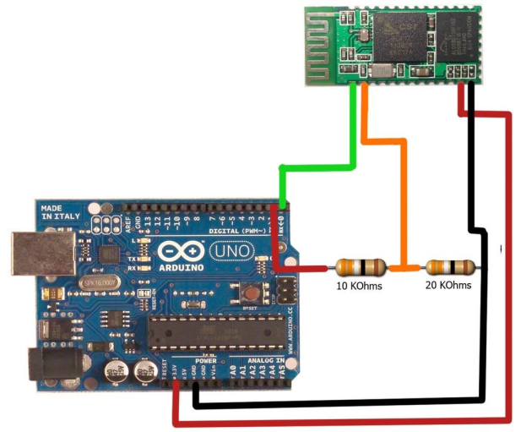

PID

Radio
I chose to go with the Orange T-Six 6 channel Transmitter. It has a number of features and was reasonably price for an entry level transmitter. I went with the mode 2 version which has the throttle on the left as I felt this would be most natural. To go along with the transmitter I chose the Orange R620 receiver which is a 6 channel receiver which matches the transmitter.
The first task I needed to complete was to “Bind” the transmitter to the receiver. This was achieved by:
- Inserting the binding plug in the “BATT” terminal of the Receiver.
- Connect and ESC to the Receiver and connect a battery to the ESC. An LED will blink rapidly in the receiver.
- Move the throttle stick to the lowest/off position. Then power on the radio.
- When the radio and receiver are successfully bound the LED in the receiver will remain solid
- Remove the binding plug now the radio and receiver are bound.
Now that the radio and receiver are paired then next task was to see if I was able to read the raw signal from the receiver using an Arduino as this will act as the mixer board. I was able to do so using the Arduino function “pulseIn”
Reads a pulse (either HIGH or LOW) on a pin. For example, if value is HIGH, pulseIn() waits for the pin to go HIGH, starts timing, then waits for the pin to go LOW and stops timing. Returns the length of the pulse in microseconds. Gives up and returns 0 if no pulse starts within a specified time out.
The timing of this function has been determined empirically and will probably show errors in longer pulses. Works on pulses from 10 microseconds to 3 minutes in length.
The raw signal had to be scaled into percentage as for the PWM output to the ESC it required a percentage.
Having the percentage was a simple task to feed the percentage to the ESC part of the code. The percentage is then scaled to a raw value which is then passed out to the PWM pin the ESC.
Successfully controlling the throttle response of a single motor allowed me to extend the argument for throttling all 4 motors.

sEOS Simple Embedded Operating System
Now that data can be read and sent from the arduino, the next challenge was putting it all together. As there are a number of tasks that need to execute, it is important that each task is given dedicated processor time.
Using a interrupt based on a timer/counter overflow, this will allow for tasks to be called periodically, also with some logic each task can be given its own set amount of time to operate.
//sEOS Simple embbedded OS

#define ledPin 13
int timer1_counter;

void setup()
{
pinMode(ledPin, OUTPUT); // configure pin 13 as the led pin

//Initialize the timer (1) - clear every thing
noInterrupts(); // disable all interupts
// Timer/Counter Control Register A
TCCR1A = 0; // normal port operation, Waveform generation mode normal Top 0xFF, interup at TOP
TCCR1B = 0; // Input Capture Noise Canceler, Input Capture Edge Slect, no clock source

// set timer1_counter to the coorect value for our intrrupt interval
// 16 bit timer
// (2^16) - 1 = 65535 Max value

// 16 MHz = 16,000,000 Hz
// 16,000,000 cycles every 1 second
// 1 cycle every 0.0625 us

// Prescaler = 256

// factoring in the prescaler value
// 0.0625 us x 256 = 16 us
// Therefore...
// 1 cycle every 16us

// How many cycles for 0.5s ?
// 0.5 / 16us = 31250
// interup generated when timer overflows
// therefore get timer start value
// 65535 - 31250 = 34285
// timer start value = 34285

// Counter will increment on each cycle

// Initial Timer value
timer1_counter = 34285;

TCNT1 = timer1_counter; // preload timer
TCCR1B |= (1 << CS12); // cs12 prescaler 256

// TIMSK1 - Timer/Counter1 Interrupt Mask Register
TIMSK1 |= (1 << TOIE1); // enable timer overflow interrupt
interrupts(); // enable all interupts
}

ISR(TIMER1_OVF_vect) // interupt service routine
{
TCNT1 = timer1_counter; // preload timer

/***** ENTER CODE HERE *****/

digitalWrite(ledPin, digitalRead(ledPin) ^ 1);

/***** END CODE *****/
}

void loop()
{
// Sleep code here
}

The above code will act as a frame work. In this code snippet the interrupt is being generated every 0.5s. This code can be replaced with a switch statement.
Switch(state)
{
case task1:
{
// Do Something
if(++time == task1_time)
{
state = task2;
time = 0;
}
}
break;

case task2:
{
// Do Something else
if(++time == task2_time)
{
state = task3;
time = 0;
}
}
break;

case task3:
{
// Do something else
if(++time == task3_time)
{
state = task1;
time = 0;
}
}

Findings

Conclusion

Problems
Blue screen with serial read in LabVIEW – need to flush the I/O buffer before read
MPU 6050 only two axis (Pitch and Roll) need a magnetometer and gyro to get yaw angle
Speed controller arming procedure and PWM
Speed controller not working correctly see video.

Recommendations

References/bibliography
TLC
http://www.tlc-direct.co.uk/Products/MT20BX4B.html?source=adwords&kw=&gclid=COi81an4tLkCFXMgtAodCRQAXQ
Bluetooth module set-up
http://www.hobbyist.co.nz/?q=bluetooth-module-configurations

MPU 6050 Code
http://playground.arduino.cc/Main/MPU-6050
MPU 9150
http://playground.arduino.cc//Main/MPU-9150

L3G4200D
3 axis gyroscope from ST
L3G4200D Datasheet
Bildr Tutorial: http://bildr.org/2011/06/l3g4200d-arduino/

ADXL345
3 axis accelerometer from Analog Devices
ADXL345 Datasheet
Bildr Tutorial: http://bildr.org/2011/03/adxl345-arduino/

HMC5883L
3 axis digital compass from Honeywell
HMC5883L Datasheet
Bildr Tutorial: http://bildr.org/2012/02/hmc5883l_arduino/

BMP085
Barometric Pressure and Temperature Sensor from Bosch
BMP085 Datasheet
Bildr Tutorial: http://bildr.org/2011/06/bmp085-arduino/

Appendices

